Data format

1. Grid network related
2. A NxN adjacency matrix for grids
3. A Nx2 numpy array to store centroid lng and lat of each zone

N is the number of zones

1. Order related
2. all_request.pickle

a dict shown as below



Each entry of the dict is another list, which contains orders as below:



Here, each entry respectively represents order_id, t_start, t_end, origin_lng, origin_lat, dest_lng, dest_lat, immediate_reward, dest_grid_id, (origin_grid_id will be provided in Siyuan’s experiment)

To note: the time interval here can be changed with flexibility

1. demand_stat

a csv file shown as below; time represents true timestamp (counted in seconds); mean and std represents the statistical measurement for the total demand within each time interval. The length of time interval can be changed with flexibility

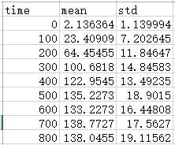

1. Driver related
2. Driver_info.csv

A csv file shown as below; start_time and end_time represent the time when the driver becomes online or offline; grid_id represents the depot grid for the driver

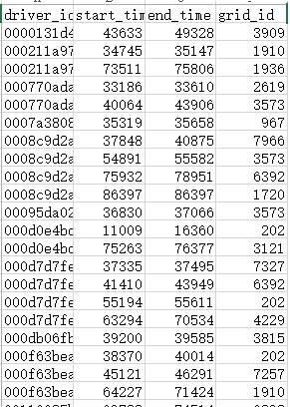

1. driver_stat.csv

mean and std are utilized to generate the total number of drivers for a whole day



Simulator logic

Process for simulator

1. 每10 min预测一次未来订单，更新predicted_pool
2. Order dispatching (先用段的 or 用km)，考虑long-term reward (extracted from value_table)以及预测订单(设置两种方式：全部展开以及基于权重), 更新predicted_pool
3. collect transitions (st, at, st+1, r) for long-term reward（先简单参照kdd的格式）, update transition_buffer
4. 更新wait_request/matched_request, order cancellation based on waiting time/pickup distance
5. Conduct reposition
6. New order generation
7. Online/offline update
8. Update next state （纯idle车辆暂时先停在原地； reposition的车辆位置实时更新；需要update predicted_pool）
9. Update time, output transition_buffer

更新对象

1. predicted_pool

an OD matrix; each entry value represents the predicted od flow from zone i to zone j within 10 minutes

1. driver_table

a pandas DataFrame object; column names are as follows

|  |  |
| --- | --- |
| status | 0 is idle; 1 is pick-up; 2 is on-trip; 3 is repositioning |
| start_time | The time stamp when the current status begins |
| end_time | The time stamp when the current status ends |
| lng | The longitude where the driver is at |
| lat | The latitude where the driver is at |
| grid_id | The grid id where the driver is currently located at |
| target_grid_id | The grid id where the current task will finish at |
| target_loc_lng | The longitude where the current task will finish at |
| target_loc_lat | The latitude where the current task will finish at |
| remaining_time | The remaining time to finish the current task |
| matched_order_id | The python str object that represents the order id matched with the driver; the str object “None” is used if no orders matched with the driver |
| total_idle_time | The total of idling time since the last time when the driver status turns to idling. 0 when the status is not idling. |

1. wait_requests

|  |  |
| --- | --- |
| 'order_id' | A str object used to identify each order |
| 'trip_time' | Trip time from the origin to the destination for each order |
| 'origin_lng' | Longitude for origin |
| 'origin_lat' | Latitude for origin |
| ‘origin_grid_id’ | Grid id for origin |
| 'dest_lng' | Longitude for destination |
| 'dest_lat' | Latitude for destination |
| 'dest_grid_id' | Grid id for destination |
| 'immediate_reward' | Real reward |
| 't_start' | The timestamp when the order coming into the system |
| 't_matched' | The timestamp when the order matched with a driver |
| 'pickup_time' | Time required for pick-up after matching |
| 'wait_time' | Waiting time the order has experienced till now |
| 't_end' | The timestamp when the order arrive its destination |
| 'status' | 0 is not matched; 1 is matched |
| 'driver_id' | The driver id matched with the order |
| 'maximum_wait_time' | The maximum of waiting time that the order allows |
| 'cancel_prob' | The probability for cancellation of the order based on pickup distance |
| 'pickup_distance' | Pickup distance counted in meter |

1. matched_requests

The format is the same as wait_requests

1. transition_buffer

a list with transitions. Each transition is in the form of [st, at, st+1, reward]. St is an numpy array of time stamp and grid id; at can be ignored here; reward is a float value.

1. value_table

required definition from Duan

Noted:

1. All the time-related object is counted in seconds, while all the distance-related object is counted in meter
2. All the six objects will be stored as a property of the simulator class. “self.xxx” is necessary when utilizing the objects.